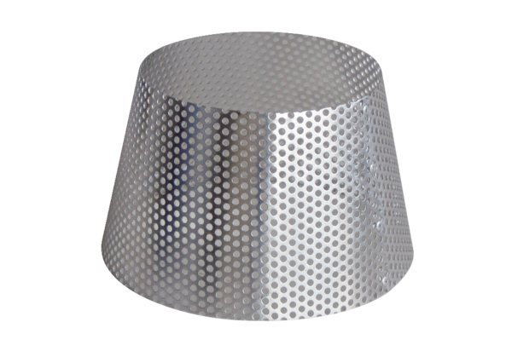Rain protection grille RG 160Packing unit: 1 pieceRange: B
Article number: 0151.0281Manufacturer: MAICO

