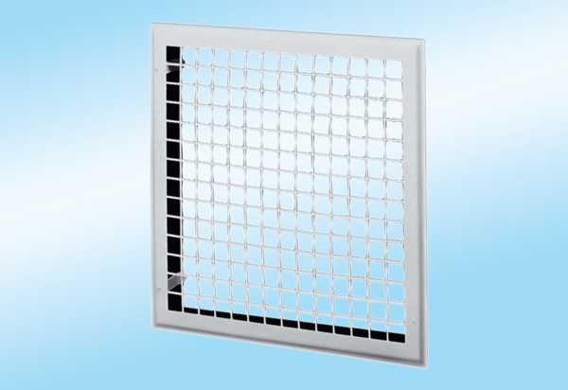Internal grille MLG 30Packing unit: 1 pieceRange: C
Article number: 0151.0063Manufacturer: MAICO

