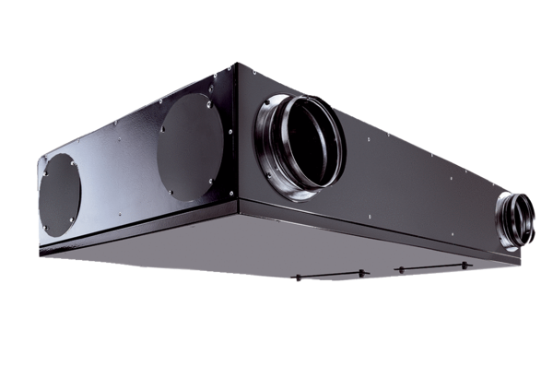Centralised ventilation unit Trio QZ-ALVPacking unit: 1 pieceRange: K
Article number: 0095.0127Manufacturer: MAICO

