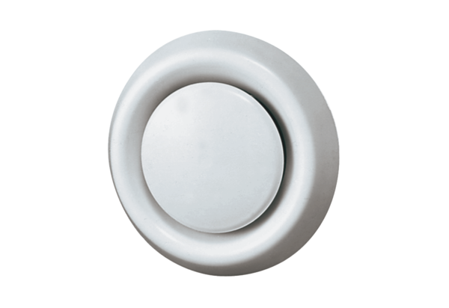Disk valve, synthetic material TK 12Packing unit: 1 pieceRange: C
Article number: 0151.0198Manufacturer: MAICO

