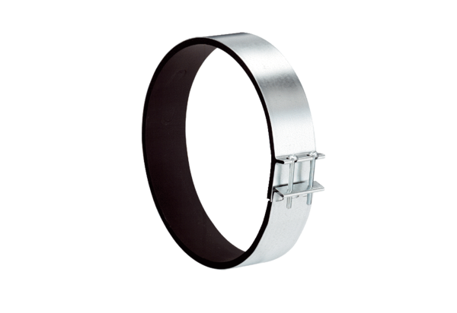Fixing cuff ELR 20Packing unit: 1 pieceRange: C
Article number: 0092.0112Manufacturer: MAICO

