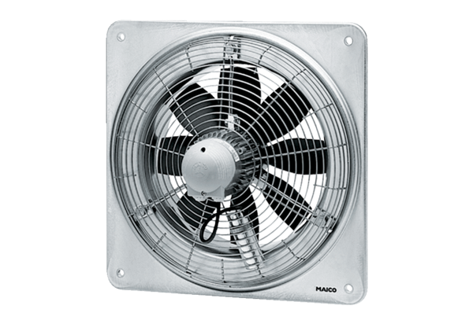Axial wall fan EZQ 25/4 EPacking unit: 1 pieceRange: C
Article number: 0083.0486Manufacturer: MAICO

