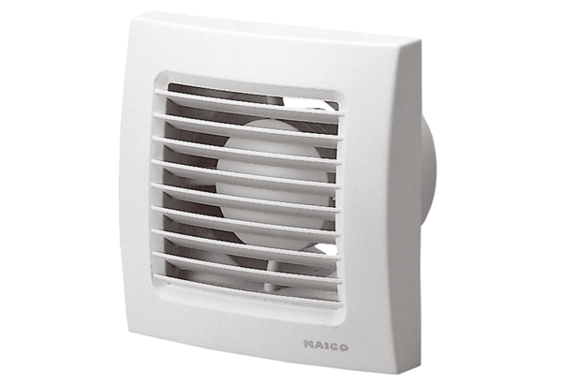Small room fan ECA 150 PPacking unit: 1 pieceRange: A
Article number: 0084.0066Manufacturer: MAICO

