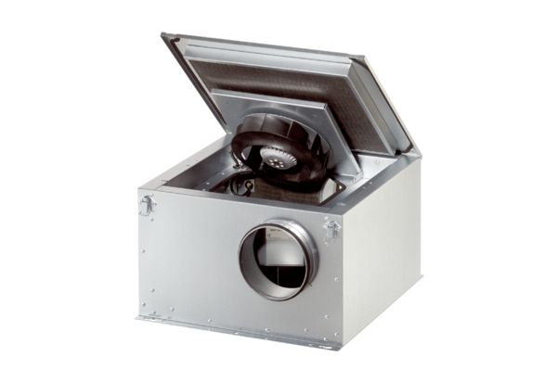Sound-insulated ventilation box ESR 16-2 ECPacking unit: 1 pieceRange: E
Article number: 0080.0711Manufacturer: MAICO

