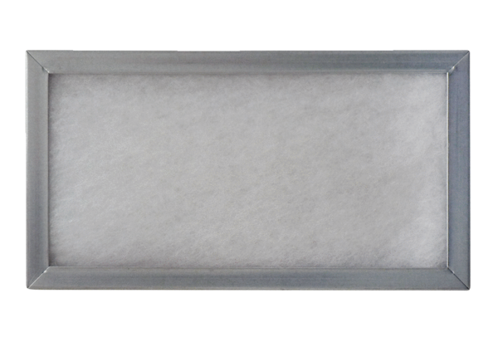Push-in frame for air filter WSG-ES 170Packing unit: 1 pieceRange: K
Article number: 0093.0269Manufacturer: MAICO

