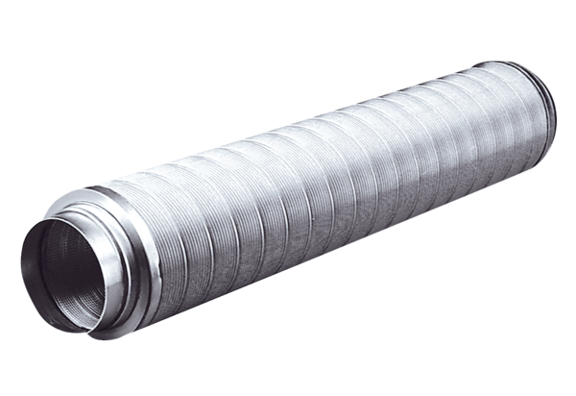Tubular sound absorber RSR 20Packing unit: 1 pieceRange: C
Article number: 0092.0316Manufacturer: MAICO

