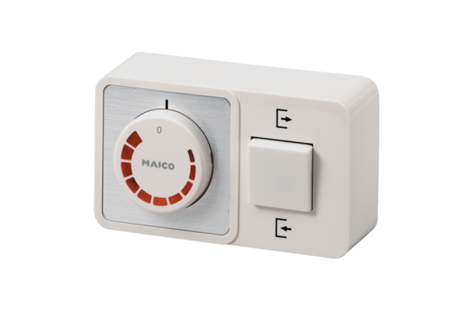Speed controller, reversing switch STW 1Packing unit: 1 pieceRange: C
Article number: 0157.0813Manufacturer: MAICO

