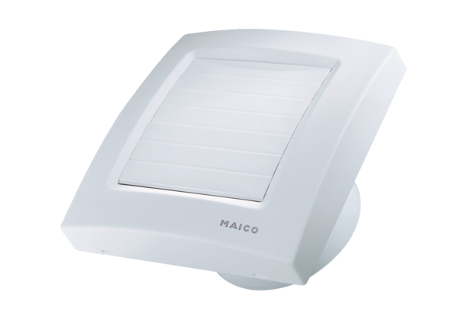Small room fan ECA 120 KPPacking unit: 1 pieceRange: A
Article number: 0084.0035Manufacturer: MAICO

