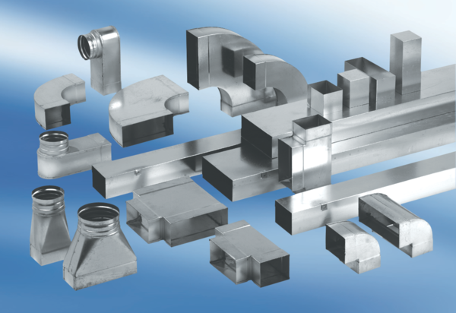Adaptor plug connector SVF80/150Packing unit: 1 pieceRange: K
Article number: 0055.0568Manufacturer: MAICO

