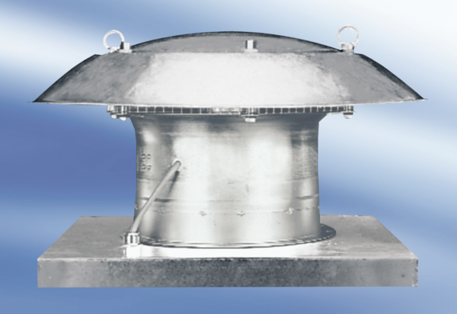Axial roof fan DZD 40/2 APacking unit: 1 pieceRange:
Article number: 0087.0423Manufacturer: MAICO

