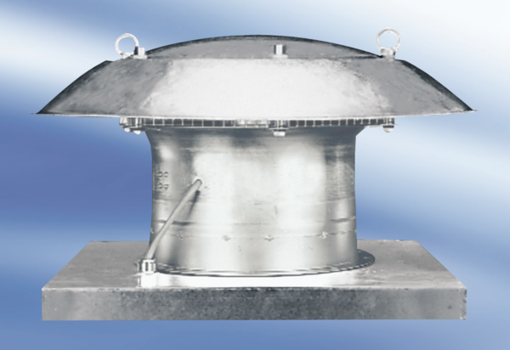Axial roof fan EZD25-2APacking unit: 1 pieceRange:
Article number: 0087.0402Manufacturer: MAICO

