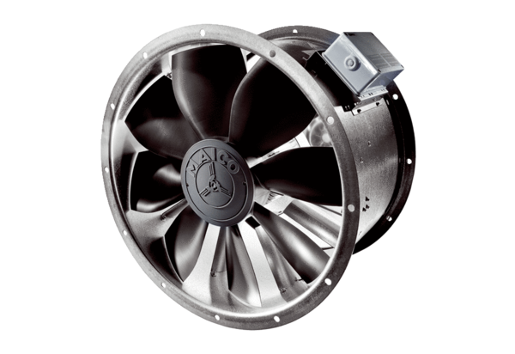Axial duct fan DZL 45/4 BPacking unit: 1 pieceRange: C
Article number: 0086.0086Manufacturer: MAICO

