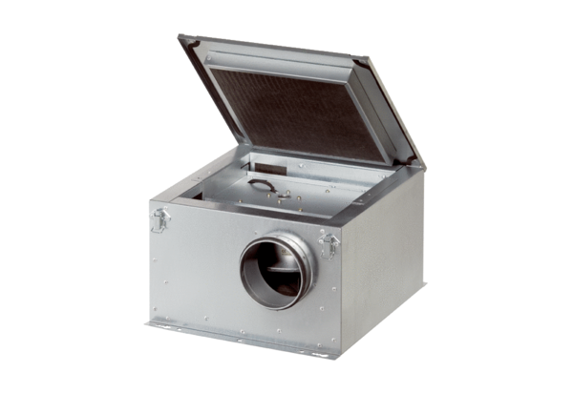Sound-insulated ventilation box ESR 20-2Packing unit: 1 pieceRange: C
Article number: 0080.0612Manufacturer: MAICO

