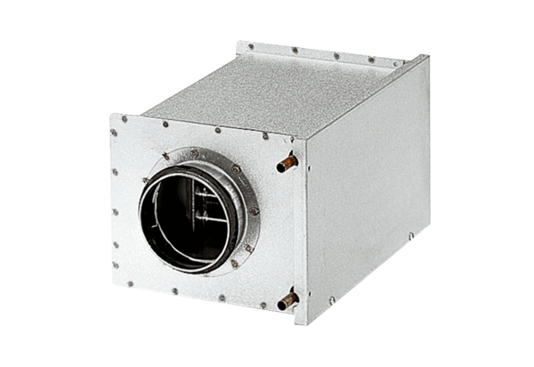Water air heater WRH 20-2Packing unit: 1 pieceRange: C
Article number: 0082.0119Manufacturer: MAICO

