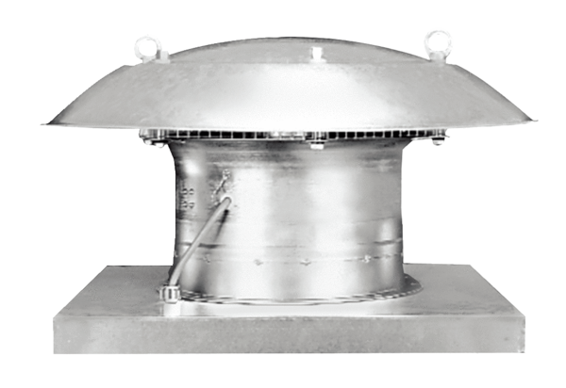Axial roof fan EZD 25/4 EPacking unit: 1 pieceRange: C
Article number: 0087.0486Manufacturer: MAICO

