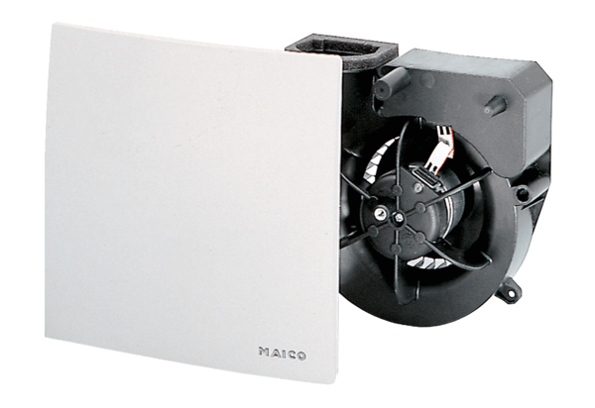Fan insert ER 60 HPacking unit: 1 pieceRange: B
Article number: 0084.0104Manufacturer: MAICO

