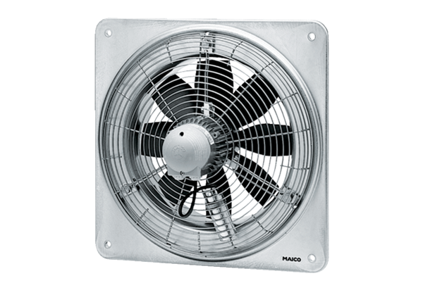Axial wall fan DZQ 30/84 BPacking unit: 1 pieceRange: C
Article number: 0083.0145Manufacturer: MAICO

