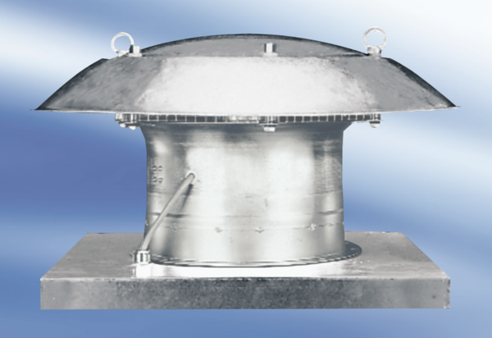Axial roof fan EZD35-4APacking unit: 1 pieceRange:
Article number: 0087.0407Manufacturer: MAICO

