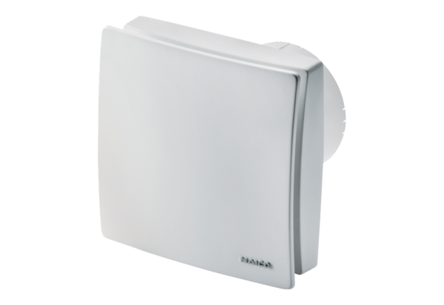Small room fan ECA 100 ipro KPacking unit: 1 pieceRange: A
Article number: 0084.0205Manufacturer: MAICO

