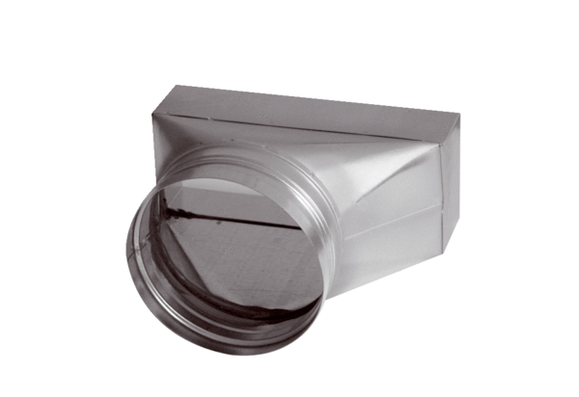Intermediate piece, asymmetric USAN80/200/150Packing unit: 1 pieceRange: K
Article number: 0055.0673Manufacturer: MAICO

