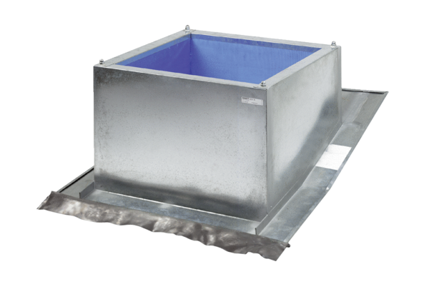Roof socket for pitched roofs SDS 31Packing unit: 1 pieceRange: C
Article number: 0093.0978Manufacturer: MAICO

