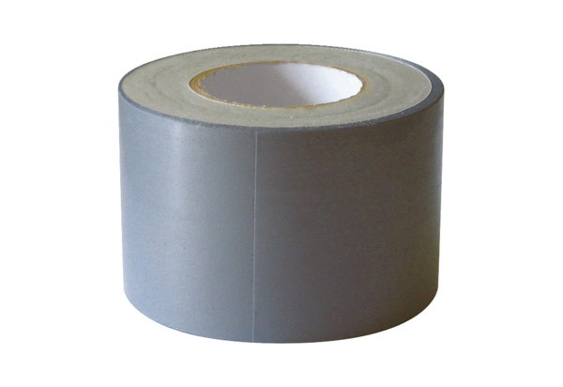Adhesive sealing tape, 25 m, 50 mm wide AK25-55Packing unit: 1 pieceRange: K
Article number: 0154.0011Manufacturer: MAICO

