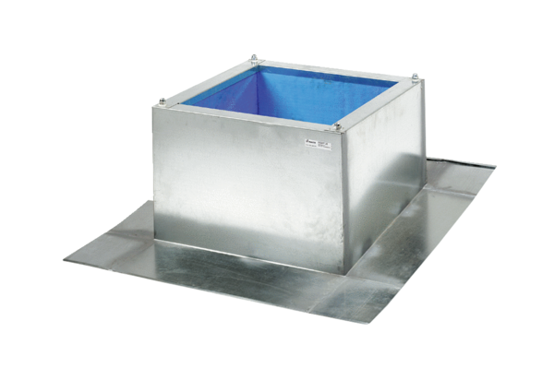Roof socket for corrugated and trapezoidal roofs SOWT 50Packing unit: 1 pieceRange: C
Article number: 0093.1032Manufacturer: MAICO

