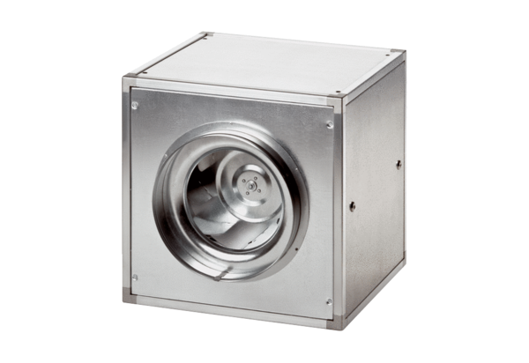Quickbox DSQ 25/4Packing unit: 1 pieceRange: C
Article number: 0080.0032Manufacturer: MAICO

