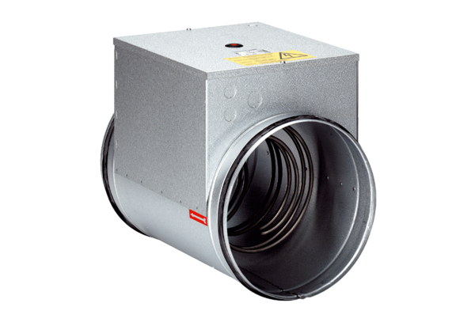Electrical air heater DRH 16-5Packing unit: 1 pieceRange: C
Article number: 0082.0105Manufacturer: MAICO

