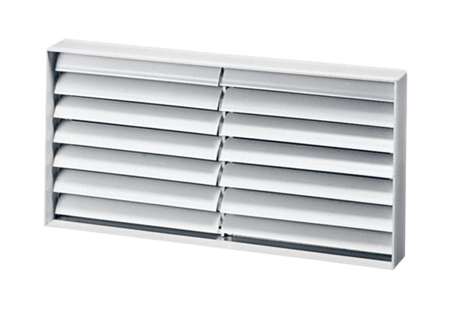Channel shutter AKP 35Packing unit: 1 pieceRange: D
Article number: 0151.0100Manufacturer: MAICO

