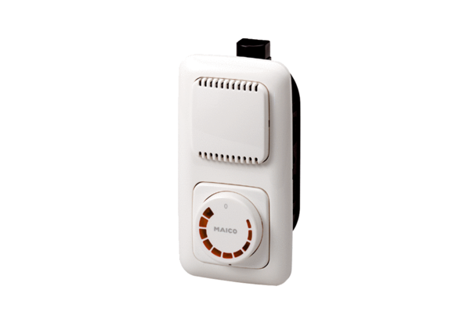Speed controller STU 5Packing unit: 1 pieceRange: C
Article number: 0157.0816Manufacturer: MAICO

