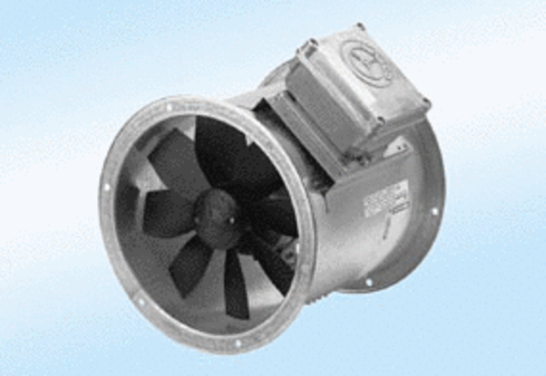Axial duct fan DZR 50/6 A-ExPacking unit: 1 pieceRange: C
Article number: 0086.0785Manufacturer: MAICO

