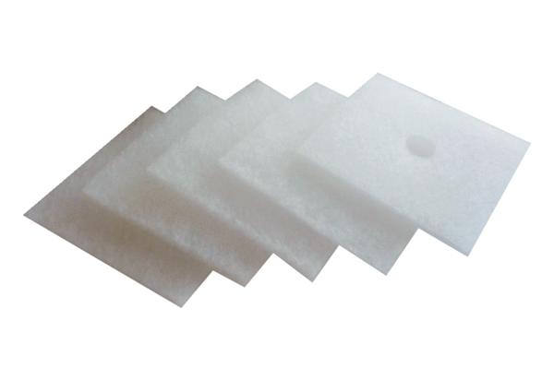Air filter, replacement ZF 60/100Packing unit: 5 piecesRange: B
Article number: 0093.0680Manufacturer: MAICO

