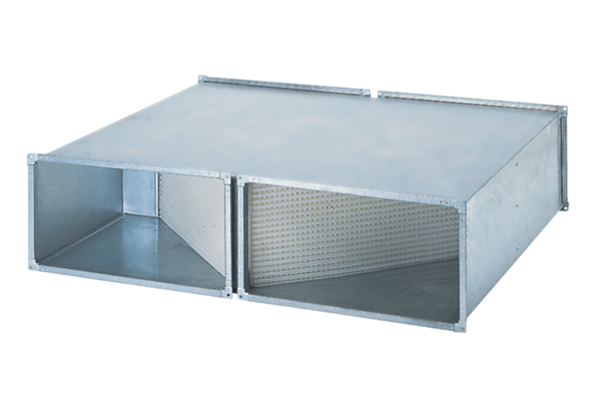Heat exchanger WT 3000Packing unit: 1 pieceRange: D
Article number: 0152.0043Manufacturer: MAICO

