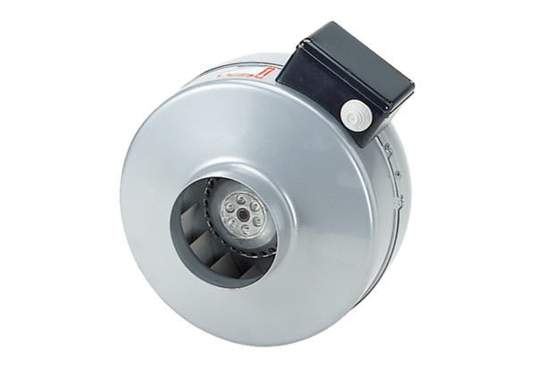Centrifugal duct fan ERR 35/1Packing unit: 1 pieceRange: C
Article number: 0080.0870Manufacturer: MAICO

