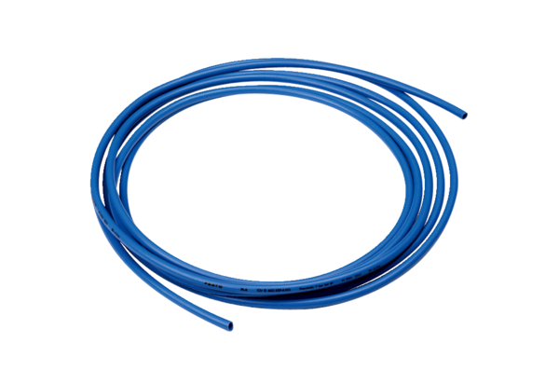Pressure tubing Centro-PPPacking unit: 1 pieceRange: B
Article number: 0092.0487Manufacturer: MAICO

