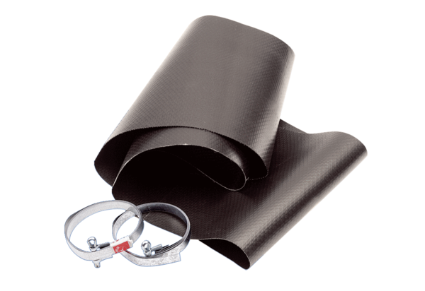Flexible cuff EL 45Packing unit: 1 pieceRange: C
Article number: 0092.0155Manufacturer: MAICO

