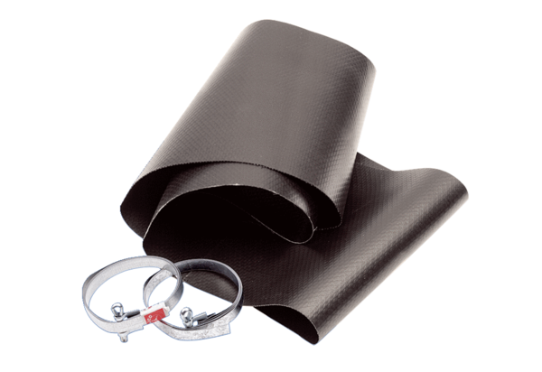Flexible cuff EL 25Packing unit: 1 pieceRange: C
Article number: 0092.0088Manufacturer: MAICO

