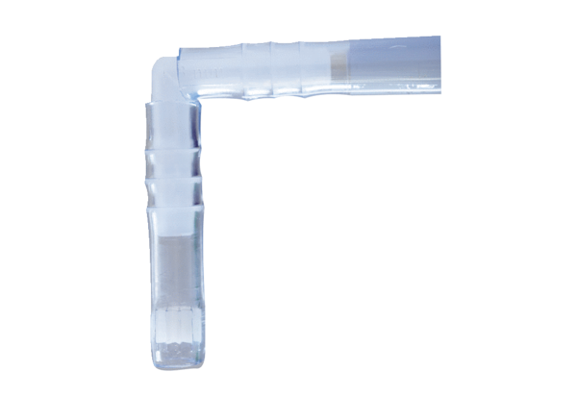Insect protection kit ISKPacking unit: 1 pieceRange: C
Article number: 0093.0604Manufacturer: MAICO

