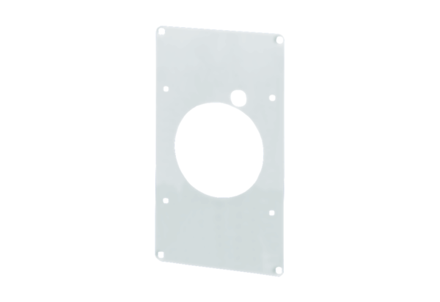Mounting plate ZM 11Packing unit: 1 pieceRange: A
Article number: 0059.0696Manufacturer: MAICO

