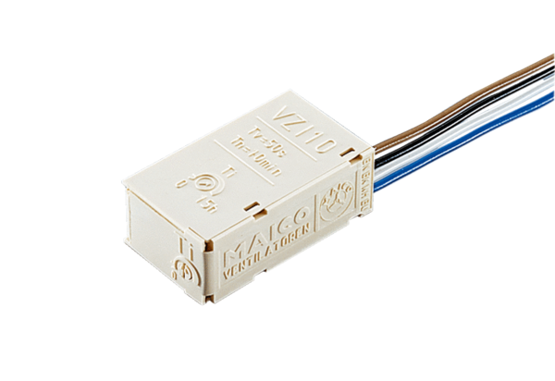Interval switch VZI 10Packing unit: 1 pieceRange: A
Article number: 0157.0823Manufacturer: MAICO

