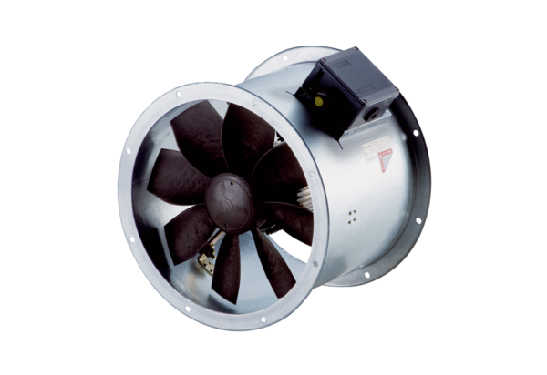Axial duct fan DZR 30/6 B Ex ePacking unit: 1 pieceRange: C
Article number: 0086.0703Manufacturer: MAICO

