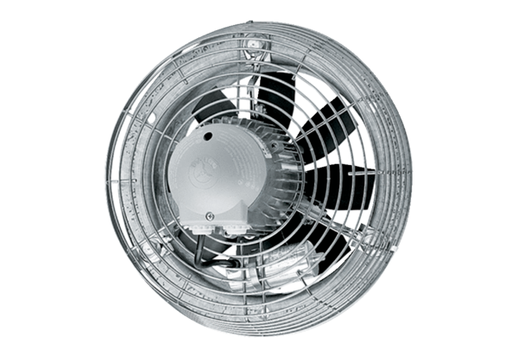Axial wall fan DZS 40/126 BPacking unit: 1 pieceRange: C
Article number: 0094.0048Manufacturer: MAICO

