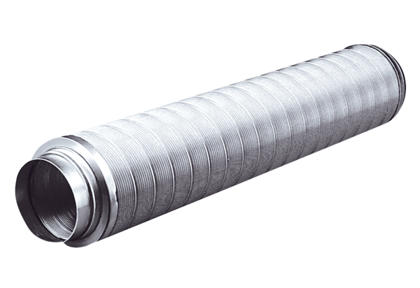Tubular sound absorber RSR 18Packing unit: 1 pieceRange: C
Article number: 0092.0315Manufacturer: MAICO

