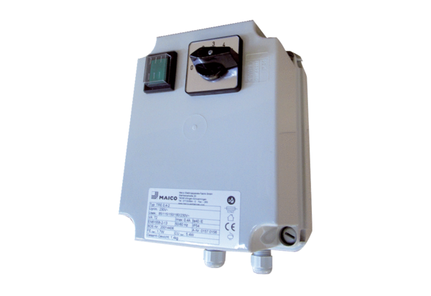5-step transformer TRE 0,4-2Packing unit: 1 pieceRange: C
Article number: 0157.0156Manufacturer: MAICO

