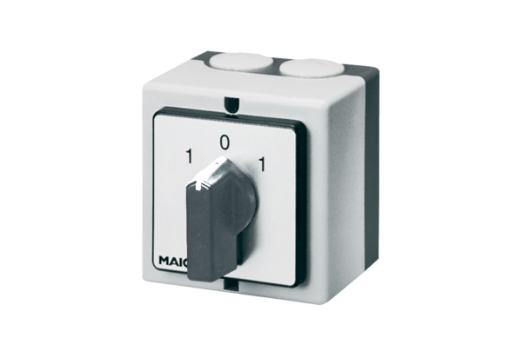Reversing switch W 1Packing unit: 1 pieceRange: C
Article number: 0157.0101Manufacturer: MAICO

