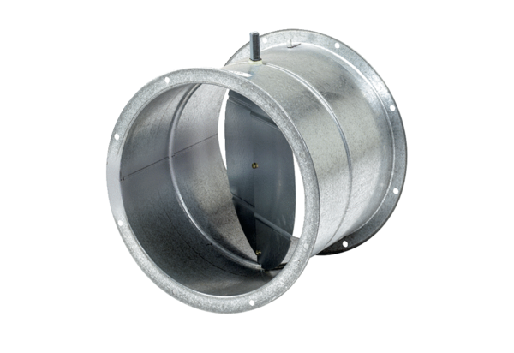Shutter, servomotor VE 50Packing unit: 1 pieceRange: C
Article number: 0093.0289Manufacturer: MAICO

