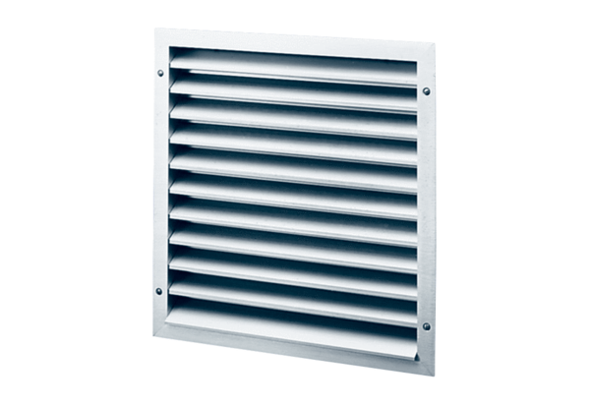External grille MLZ 50Packing unit: 1 pieceRange: C
Article number: 0151.0106Manufacturer: MAICO

