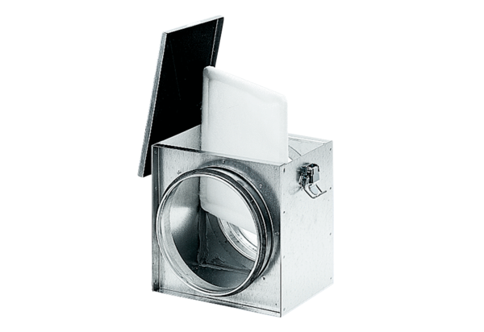Air filter TFE 35-4Packing unit: 1 pieceRange: C
Article number: 0149.0081Manufacturer: MAICO

