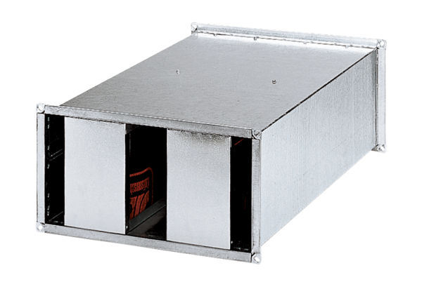Channel sound absorber KSP 93/28Packing unit: 1 pieceRange: D
Article number: 0092.0504Manufacturer: MAICO

